Session 7: Date Functions and Time Management
1. Objective
To implement date-based logic in the Project-Hub application for tracking project durations, calculating expiry dates, and analyzing submission patterns.

2. Implementation Queries
First, we need to add date columns to your existing tables so we have data to work with.
ALTER TABLE Course ADD COLUMN start_date DATE;
ALTER TABLE Course ADD COLUMN end_date DATE;
UPDATE Course SET start_date = '2026-01-01', end_date = '2026-02-15' WHERE Course_Code = 'FS101';
UPDATE Course SET start_date = '2026-01-10', end_date = '2026-03-20' WHERE Course_Code = 'ML202';
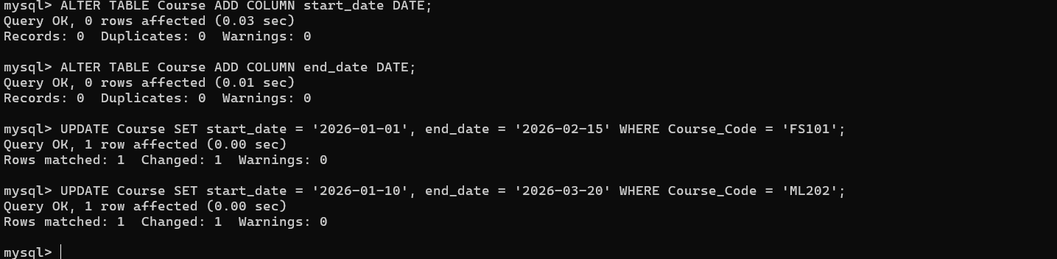

Task 1: Calculate Project Duration
Find the number of days between the start and end of a project.
SELECT Course_Name, DATEDIFF(end_date, start_date) AS Total_Days FROM Course;
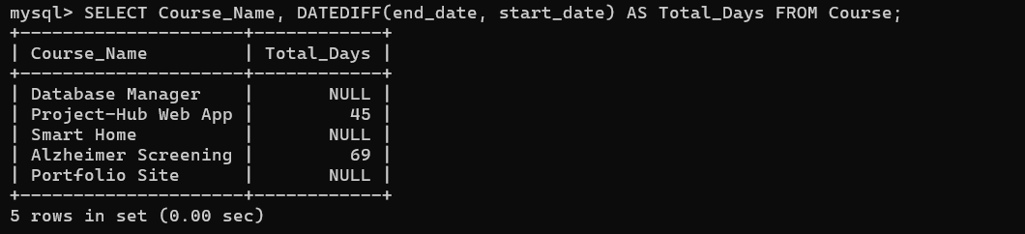
Task 2: Calculate Future Deadlines
Find the expiry date for a project access key exactly 30 days from today.
SELECT CURRENT_DATE() AS Today, DATE_ADD(CURRENT_DATE(), INTERVAL 30 DAY) AS Expiry_Date;
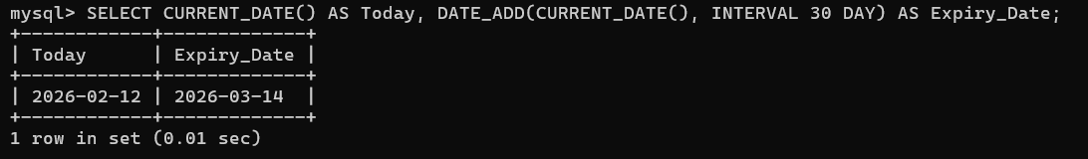
Task 3: Historical Data Retrieval
Get the date exactly seven days before today to check recent logins.
SELECT DATE_SUB(CURRENT_DATE(), INTERVAL 7 DAY) AS Last_Week_Date;
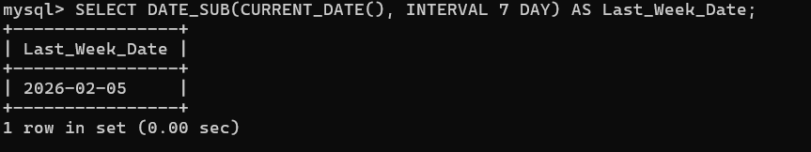
Task 4: Weekend Activity Analysis
Identify projects created on weekend dates (Saturday=7, Sunday=1).
SELECT Course_Name, start_date FROM Course WHERE DAYOFWEEK(start_date) IN (1, 7);
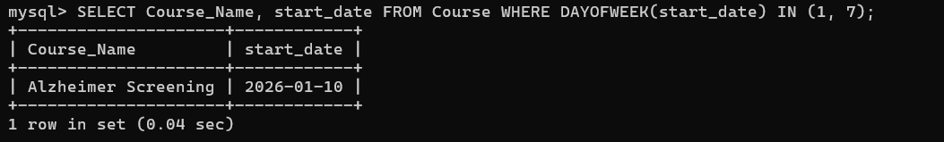
Task 5: Date Formatting and Month Extraction
Read a date and display the month name in a specific format.
SELECT DATE_FORMAT('2026-02-12', '%d-%m-%Y') AS Formatted_Date, MONTHNAME('2026-02-12') AS Month_Name;
